**Assignment 2**

Makar Riabcev (2633590)

**Rqt graph**

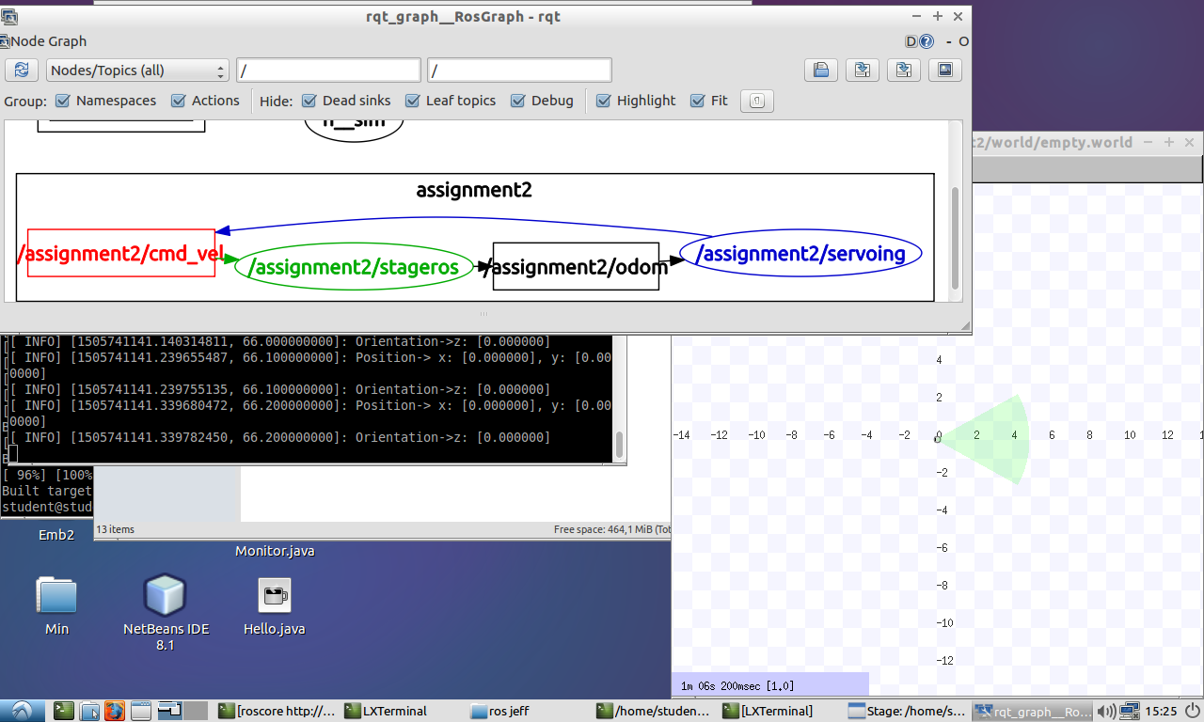

**Result of pointshoot node**

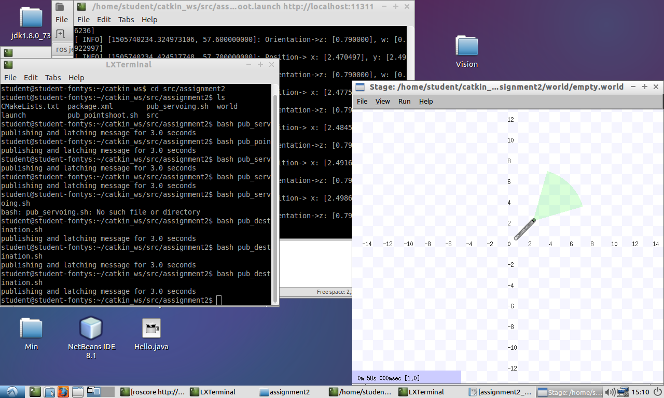

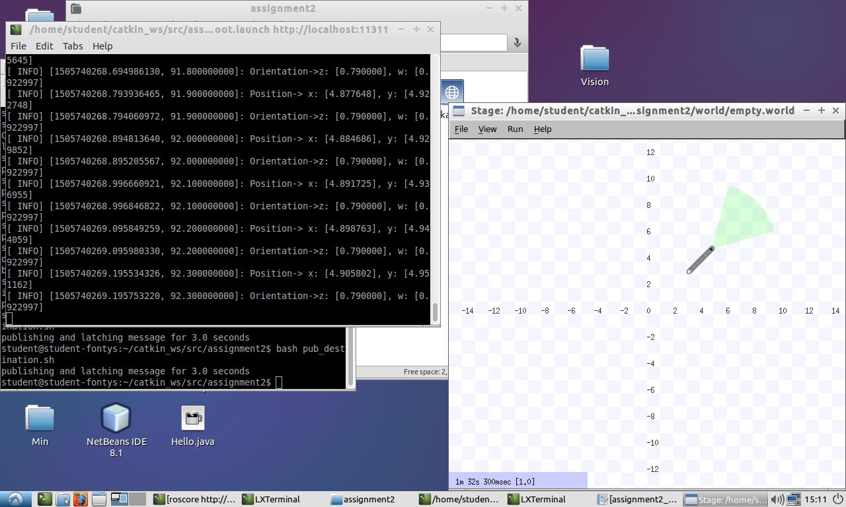

**Result of servoing node**

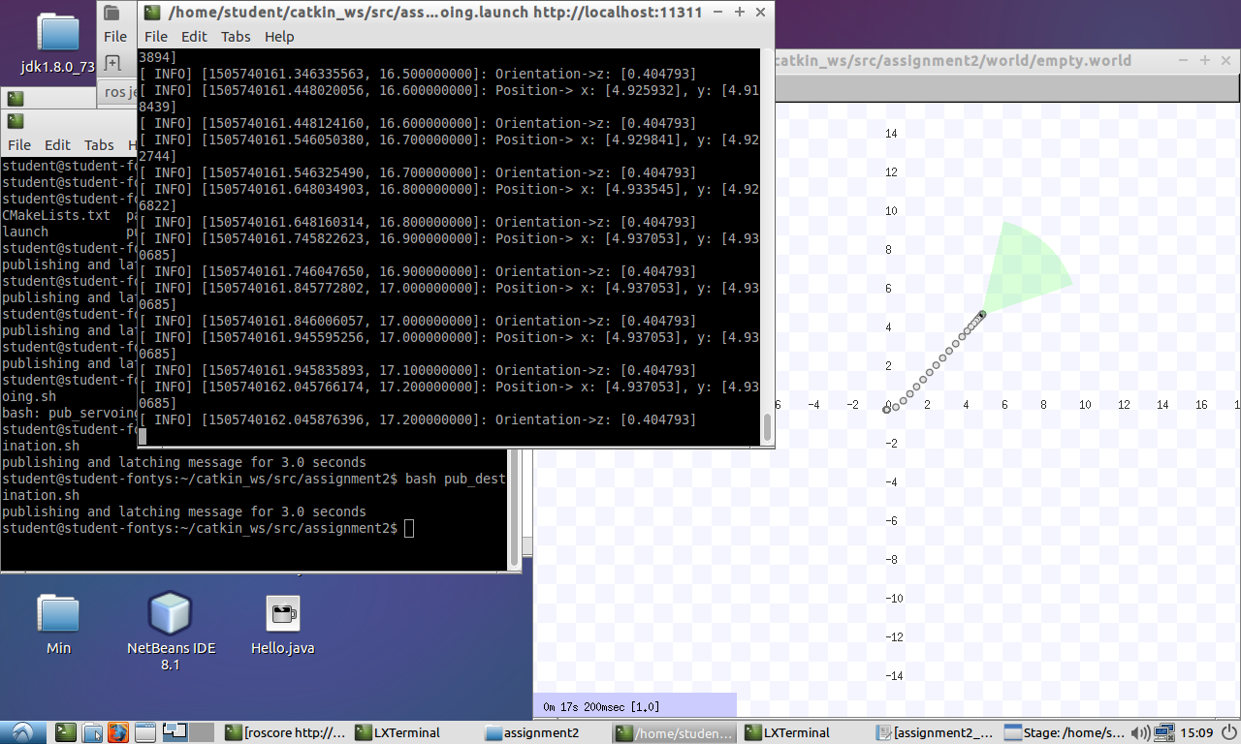

**Comments:**

For both of these nodes the /odom topic subscribed to the node, and the node publishes /cmd_vel message.

The position of the robot displays all the time in the terminal window.

To be able to give a goal point to the robot it’s needed to write in terminal or create a bash script (in our case it’s pub_destionation.sh) *rostopic pub -1/assignment2/goal geometry_msgs/PoseStamped* (this message contains of Header header and Pose pose)

The difference between pointshoot node and servoing node is in the efficiency. For pointshoot node, the robot at first must rotate towards the goal and only then it moves, what takes more time then servoing node, where robot starts move immediately and rotates towards the goal during moving.

To test both of these methods the destination point was given x=5, y=5, z=0 and orientation=1.

Pointshoot method took more than 1 minute to reach the destination point

Servoing method took about 8-10 seconds to reach the destination point, what shown us, that it’s pretty efficient.